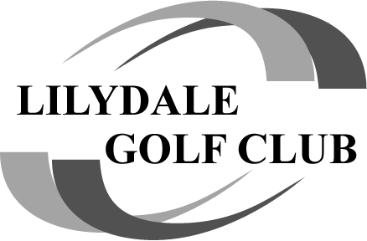

 Team Valena Triumphs as Bayviews Delivers an Ambrose Classic!
The annual Bayviews Ambrose once again proved why it's one of the favourite events on the Lilydale Golf Club calendar, with 27 players combining skill, teamwork and a healthy dose of friendly banter for a fantastic day on the course.
When the final putts dropped, it was the team of Tony Valena, Shaun Gray, Derek Barr and James Griffith who emerged victorious, producing an outstanding nett score of 52.00 to claim the Bayviews Ambrose title. Their consistent play across all 18 holes proved too strong for the chasing pack.

 The Podium
 Tony Valena / Shaun Gray / Derek Barr / James Griffith – 52.00 nett
 Ray Robertson / Peter Zammit / Andrew Clark / Ken Griffith – 54.38 nett
 Jay Callow / Michael Roach / George Karvellas / Shaun Shand – 54.88 nett
With less than three shots separating the top three teams, the competition remained alive right to the final holes.

 Shot of the Day... Make That the Shot of the Year!
The biggest cheer of the afternoon belonged to Adrian Bond, who achieved every golfer's dream with a spectacular Hole-in-One on the 15th hole! 
An ace is a once-in-a-lifetime moment for many golfers, and Adrian's perfect strike instantly became the talking point of the day. Congratulations on an unforgettable achievement!
As the famous saying goes, you don't need to draw pictures do we Bondy!! OFF A TREE.... I was lucky enough to be standing on the 16th tee box and saw it all unfold.. Amazing 
That's Bondy's 2nd hole in 1..... 22 years apart!

 Pinpoint Precision
Nearest-to-Pin honours went to:
- Peter Zammit – 5.8m
- Tony Valena – 2.48m
- Colin Peterson – 3.8m
- Adrian Bond – Hole-in-One!
- Colin Peterson – 1.1m
Another reminder that great teamwork still needs some individual brilliance.

 Teamwork Wins the Day
The Ambrose format showcased exactly what club golf is all about—backing up your teammates, celebrating the great shots and laughing off the bad ones. Every team had moments to shine, making for another memorable day at Bayviews.
Congratulations to all the prize winners, and a special salute to Team Valena for taking home the silverware. But the story everyone will be talking about for years to come is Adrian Bond's incredible hole-in-one—the perfect exclamation mark on a brilliant day of golf.
Another outstanding Lilydale Golf Club event… bring on the next one! 

