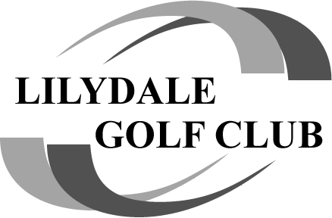

It's a tie in the Lilydale Plate!
Round 2 of the Lilydale Plate brought 27 players to Lang Lang, with the course providing a fair but testing challenge. You couldn't have asked for a better day weather wise.. Absolutely perfect! The course magnificent, fairways were like carpet. Lang Lang has been doing a lot of improvements to the course and it's showing.
The standout performance of the day came from Geoff Dyker, who delivered an impressive 36-point round to claim a clear victory. His consistency across the card separated him from the pack and secured top honours.
Behind him, the competition was fierce, with Michael Roach and Ray Zammit both finishing on 32 points. A countback was required to split the pair, awarding Roachy second place and Zammit third on the podium. Close behind, Ray Robertson and Tony Bremner both posted 31 points to round out the top five. CCR was 32 for the day, not a good day for the handicapper. The secret 6 and six pack of beer was won by Matty Scott on 14pts. Naga was played by Shauny H, unfortunately it was lost early. $20 into the tin. Naga for the day was won by Chris Taylor on 17pts.... can lose it at Yering mate, no water there

We welcomed new player Peter Zammit to the group, (son of Ray Z) hope you enjoyed the day Pete... I'm sure you'll be back 
On-course competitions added further excitement throughout the day. Alex Clarkson and Ray Robertson were standout performers each claiming multiple wins, while Geoff Dyker also featured among the NTP winners. Peter Zammit made an immediate impression in his debut round, taking out the NTP on the 12th. What about the short dog leg 14th.... NOGE to get ntp 2nd shot..... or did you just not write your name on the marker Ray Z 
Birdies were spread across the field, with Ray Robertson leading the way with two, while Geoff Dyker and Tony Valena also featured on the birdie list. Longest drives om the uphill par 5 7th were won by Ray Z (A), Andrew K (B), James G (C) and Jock taking out 65 & over. Well done lads.
Well, how wrong was I when I announced there was a winner for the Lilydale plate, I clearly can't add up correctly. But after checking all scores, there is a tie for the plate.... so a playoff at Yering!!! Tied at the top both on 145 is Geoff Dyker and Tony Bremner. The hard luck story only 1 shot behind was KB who ended on 146. Bad luck KB.
So, good luck to Tony and Geoff, you still have 1 more stroke round to go. (I might have to slot myself in that group to keep an eye on things )
See you all at Yering. (bring lots of balls!!!)

